Removal Procedure
- Disconnect the negative battery cable. Refer to Battery Negative Cable Disconnection and Connection in Engine Electrical.
- Recover the refrigerant. Refer to Refrigerant Recovery and Recharging.
- Drain the cooling system. Refer to Cooling System Draining and Filling in Engine Cooling.
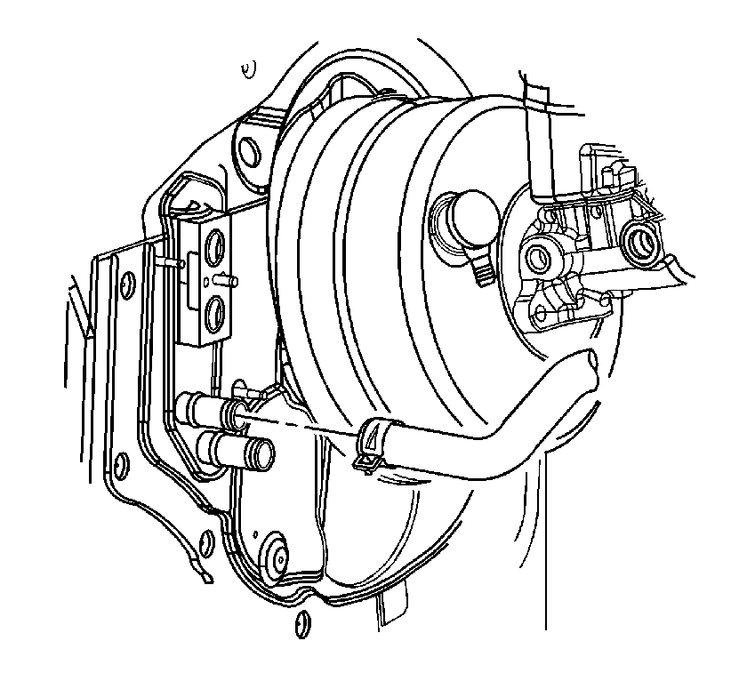
- Reposition the heater outlet hose clamp at the heater core using J 38185.
- Remove the heater outlet hose from the heater core.
- Position the hose upright against the front of dash.
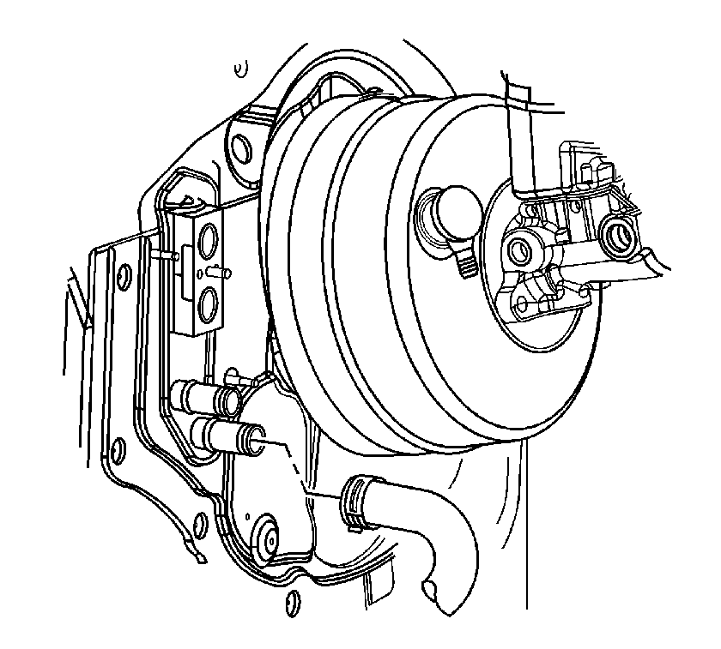
- Reposition the heater inlet hose clamp at the heater core using J 38185.
- Remove the heater inlet hose from the heater core.
- Position the hose upright against the front of dash.
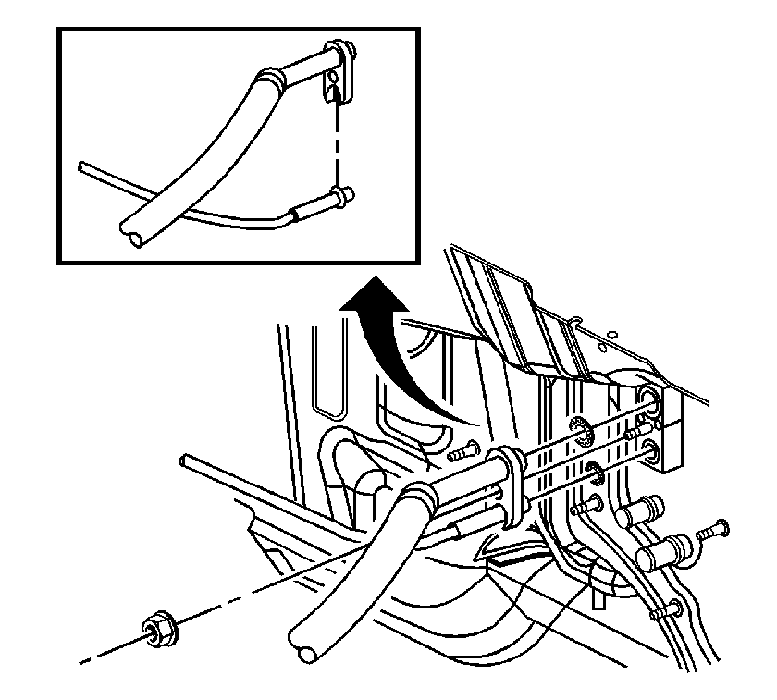
- Remove the condenser tube and evaporator hose from the thermal expansion valve (TXV).
- Remove and discard the seal washers.
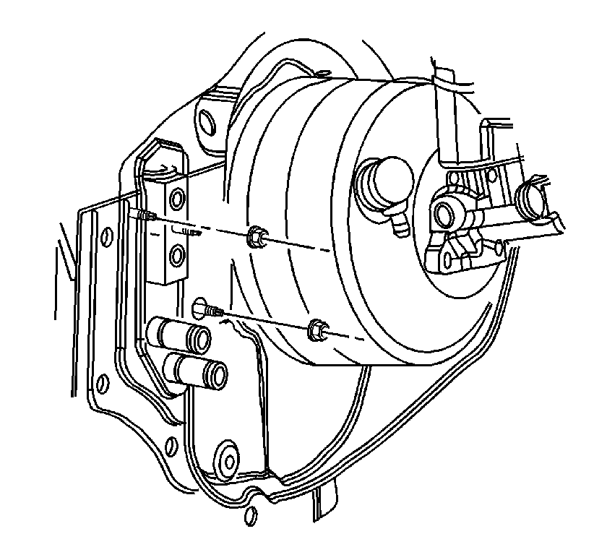
- Remove the HVAC module nuts from the front of dash.
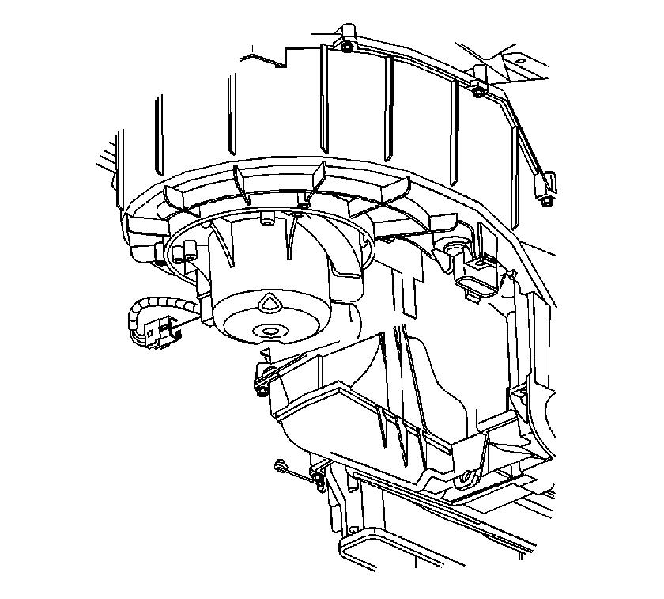
- Disconnect the blower motor connector.
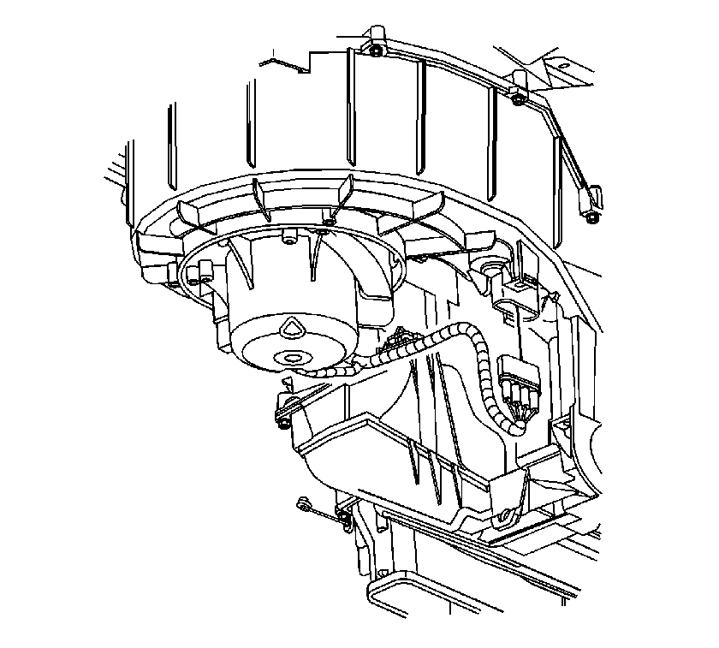
- Disconnect the blower motor resistor electrical connector.
- Remove the instrument panel (I/P) tie bar. Refer to Instrument Panel Tie Bar Replacement in Instrument Panel, Gauges, and Console.
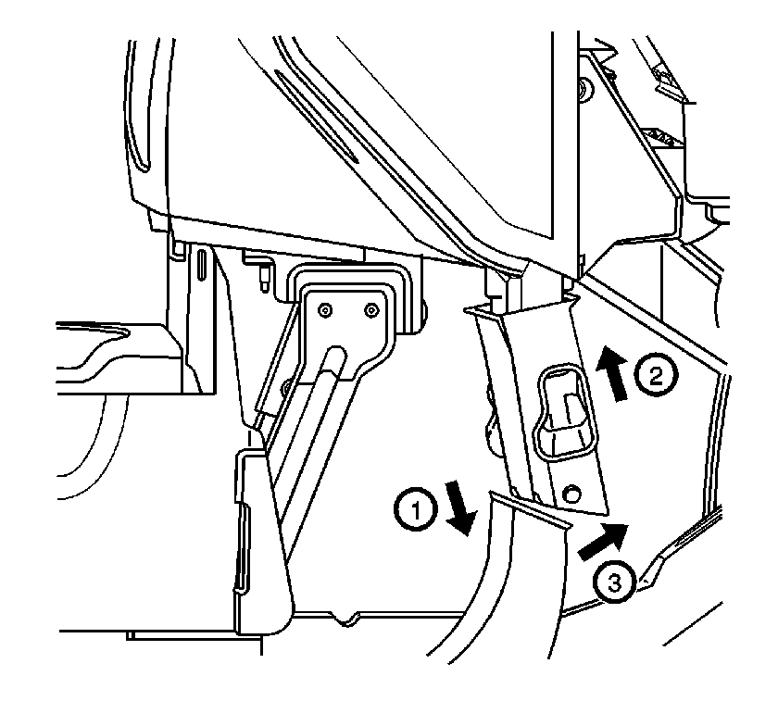
- Raise the center floor outlet duct while pushing the floor ducts down to disengage the ducts.
- Rotate the center floor outlet duct forward in the vehicle and pull down to disengage the duct from the HVAC module.
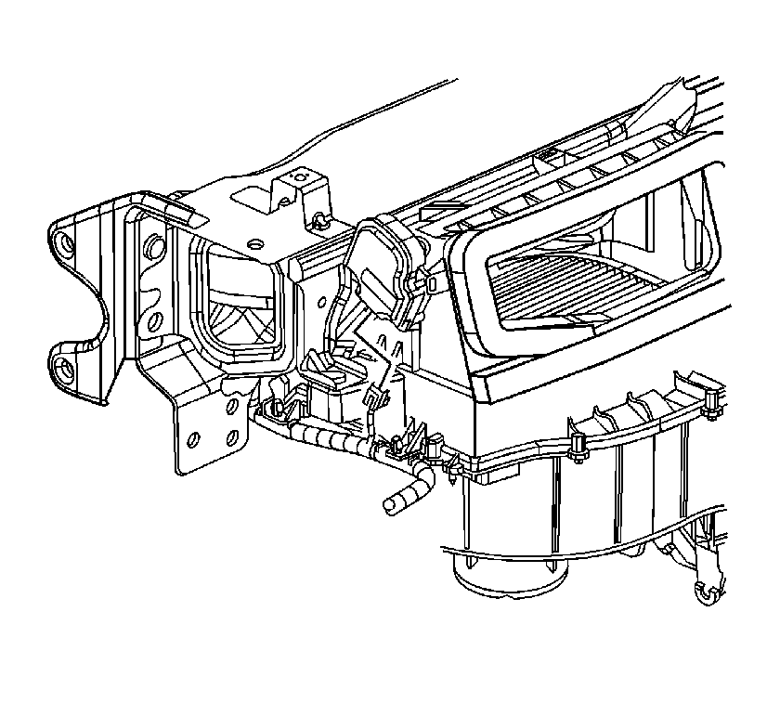
- Disconnect the recirculation actuator electrical connector.
- Remove the HVAC module from the vehicle.

